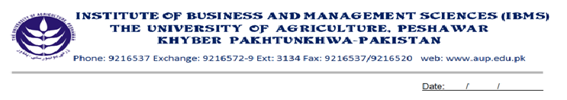
Program: BS (IT)-V
Course Name: Probability & Statistics
Course Code: MT-501
Course Hours: 03
Total Weeks: 16
Total Hours: 48

Course Objectives

The basic concept of this course is to know what is statistics and why it plays very important role in our life and where we use it. Here we also discussed the role of Probability in our life and we can find the averages and description and dispersion the relationship b/w statistics and probability.
Week-1
Introduction
- Introduction, meaning and definition of statistics
-Main divisions of statistics
-Main object of statistics
-Measures of central tendency or Average

Week-2
-Types of Averages
-The Arithmetic Mean
-Properties of the Arithmetic Mean
-Mean form Grouped Data.

Week-3
-The Geometric Mean
-The Harmonic Mean

Week-4
-The Median
-The Mode

Week-5
-Quantiles

Week-6
-Relation between different Averages
-Measures of Dispersion

Week-7
-Rang
-The semi-integrative range or the quartile deviation
-The mean deviation
Week-8
-The variance and standard deviation

Week-9
PROBABILITY
-Introduction
-An aside-sets
-Subsets
-Venn diagram

Week-10
-Operations of sets
-The algebra of sets
-Partition of sets
-Class of sets
-Cartesian product sets

Week-11
-Random experienced
-Sample space
-Event and symbolic representations
Counting Sample points

Week-12
-Definitions of Probability
-Laws of Probability

Week-13
-Condition Probability

Week-14
REGRESSION
-Introduction, Meaning and definition of Regression
-Simple linear Regression Model

Week-15
-Multiple linear regression models
-Lest Squares regression line

Week-16
-Assumptions about the model
-Properties of lest squares regression line
-Multiple linear regressions with tow regression

Total Marks: 100
Recommended Books:

- Compilers by Alfred V. Aho, Ravi Sethi, Jeffrev D. Ullman
- Introduction to computer theory by Daniel I.A.Cohen.
- Fisher. Crafting a Complier with C. Addison-wesely.

